MIDI nodes design

Abstract :

Animation nodes is an extension, an add-on to Blender.
Animation nodes have already capability to use sound spectrum for creating animation.

The purpose of MIDI nodes is to provide capability to use MIDI events as source for animation.
MIDI is an official codification of protocol between musical interfaces. MIDI file is the codification of music sheet intended for storage.

Objectives :

Creating few nodes for managing animation from MIDI file data.

Node : "MIDI File"

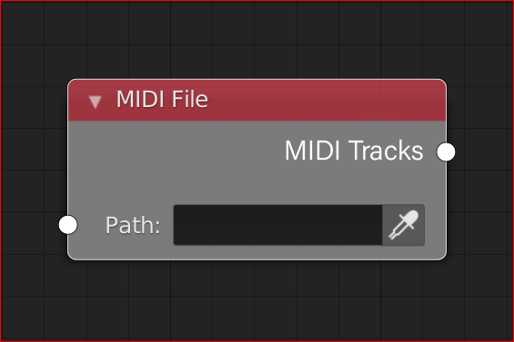
Input : Path (Socket Text)
Output : MIDI Tracks => new socket. Contains all tracks data

Description : This node load the MIDI file choosen and create output socket wich contain all tracks data sequenced in second real time instead of MIDI time.
Node : "MIDI Track"

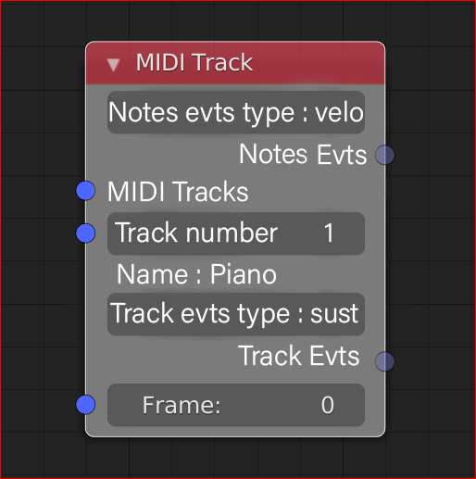

Input : MIDI Tracks (New socket)
Input : Track Number (Socket integer)
Input : Frame (Socket integer from « Time info node» most of the time)
Output : Note Evts (Socket list, one value per note)
Output : Track Evts (Socket integer)

Props :

Notes Evts Type :
None None
velo Velocity Default
aft AfterTouch

Track Evts Type :
None None Default
Sust Sustain Pedal
PitW Pitch wheel
Mod Modulation wheel

Description :

From Tracks DATA provided by MIDI file node and with somes props and with current frame, this node manage as output two type of event, one for note and one for track.

Output notes evts may be a list with values of property (ie : velocity or aftertouch)
Output track evts may be an integer value of property (ie : sustain pedal, Pitch wheel, Modulation wheel, etc.)

If user need other event for notes for example, he need to have a second (third, etc.) MIDI Track node to manage it.

Later, in a second time we can think about a MIDI node RT to provide input informations on the MIDI tracks socket.

Constraints :

For now, only MIDI file type 0 and type 1 are supported. Type 2 is used rarely.

